Kurosh Farsimadan

DESIGN DOCUMENT FOR VUE STARTER PACK PROJECT

##### 

**TABLE OF CONTENTS**

1 introduction 3

2 application design and mockups 3

3 application requirements 6

1. First step - show a list of uploaded files in a table format (date, time + file name) 6

2. Second step - selecting 1 out of 4 box options - a selection must happen for the user to be able to proceed to the next step 6

3. Third step (Q/A) - entering in 4 field forms: name, address, email and phone number, there must be form validation 6

4. Last step - overview screen of all information collected where they have to confirm before submitting 6

4 Used libraries 6

1. Vue.js 2 6

2. Bootstrap 4 6

3. Vue-Tel-Input 6

REFERENCES 6

# introduction

The aim of this application is to showcase Vue.js functionality with Bootstrap. Throughout the application code review, you might see comparative usage of different Javascript or Vue.js built-in core functions in seeing how or what different ways you have in implementing a small application like this.

I have also tried to comment the application wherever I saw necessary. This application does not follow all of the recommended Vue.js practices, but I have commented in places where I customized my own solution in the application.

# application design and mockups

In the first screen, you can see that we have a file table screen where the user has to select 1 relevant file. Checkbox functionality could have been also used (figure 1 & 2).

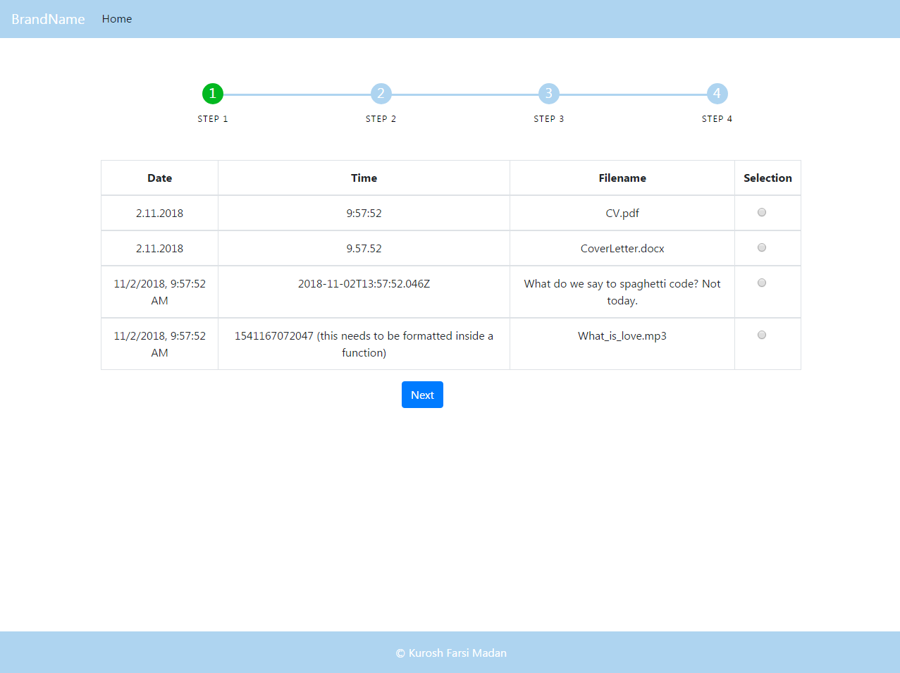

Figure 1. Step 1

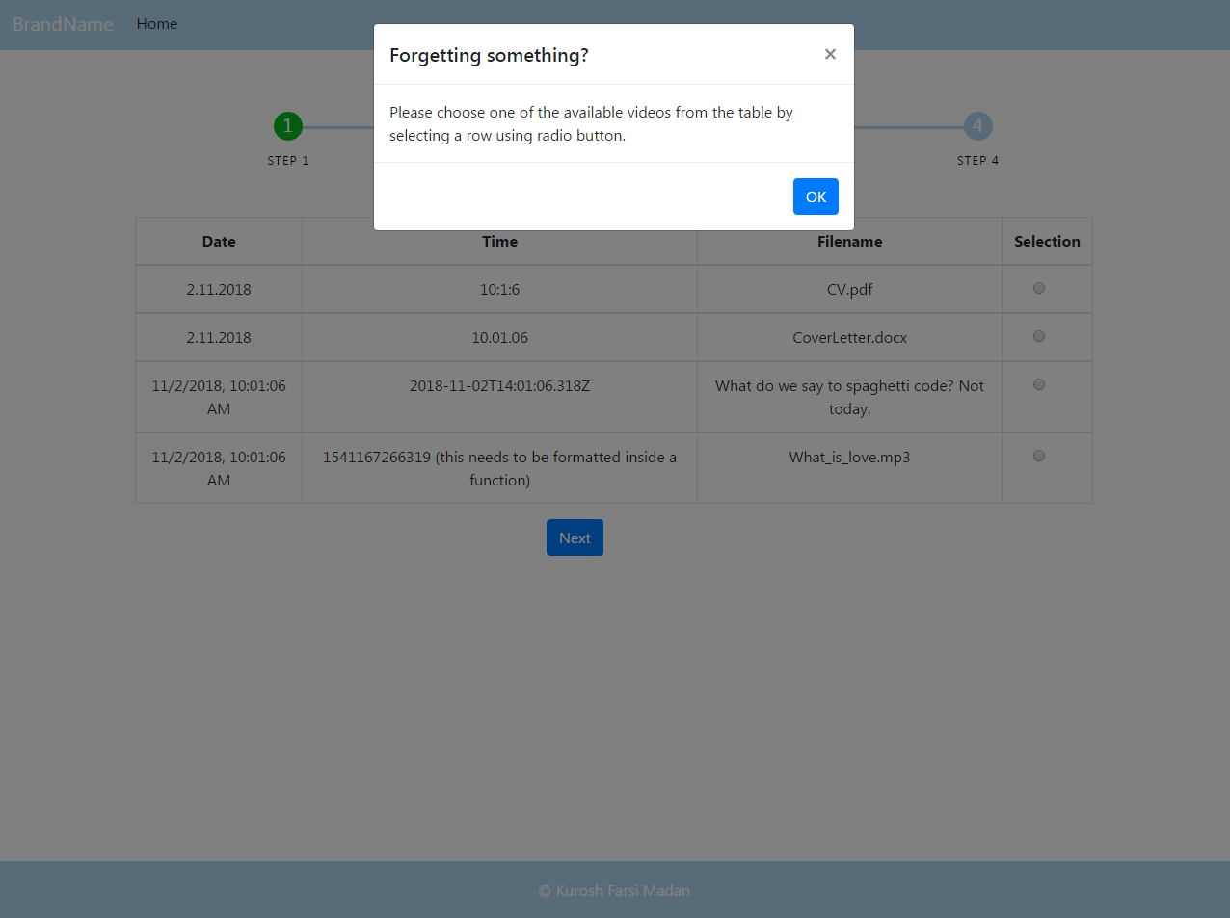

Figure 2. Step 1 error

In the second screen and step after selecting a file and pressing “Next” button, you can see that you have 4 box select options. You must choose the sex, or else, you won’t be able to proceed.

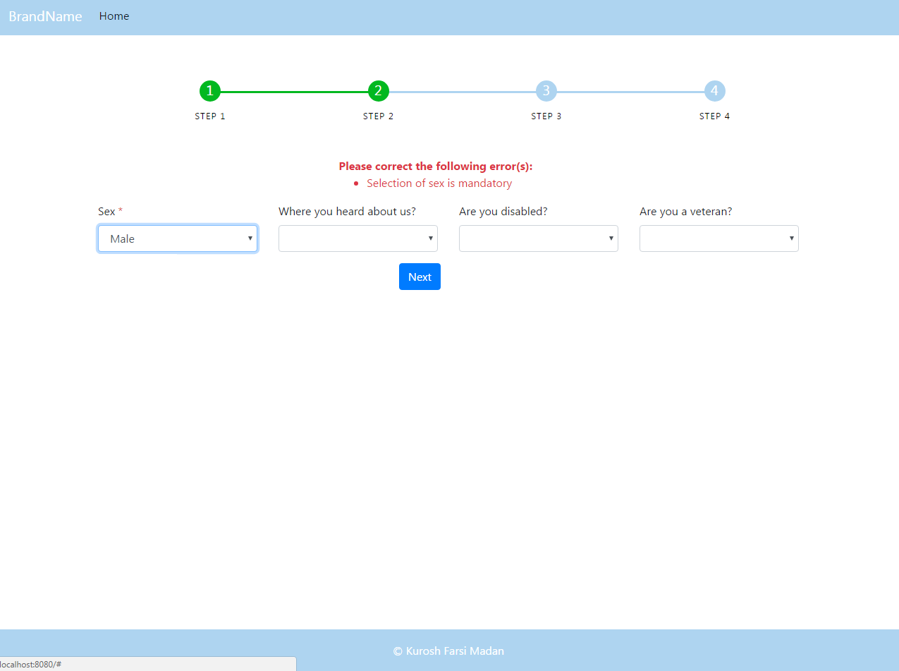

Figure 3. Step 2

In the third screen and step, you need to enter your information. You can ignore the radio buttons and checkbox since they are just for filling out the screen. Although, responsiveness was not the main concern in this app, I did use Bootstrap grid system as can be seen in figure 5.

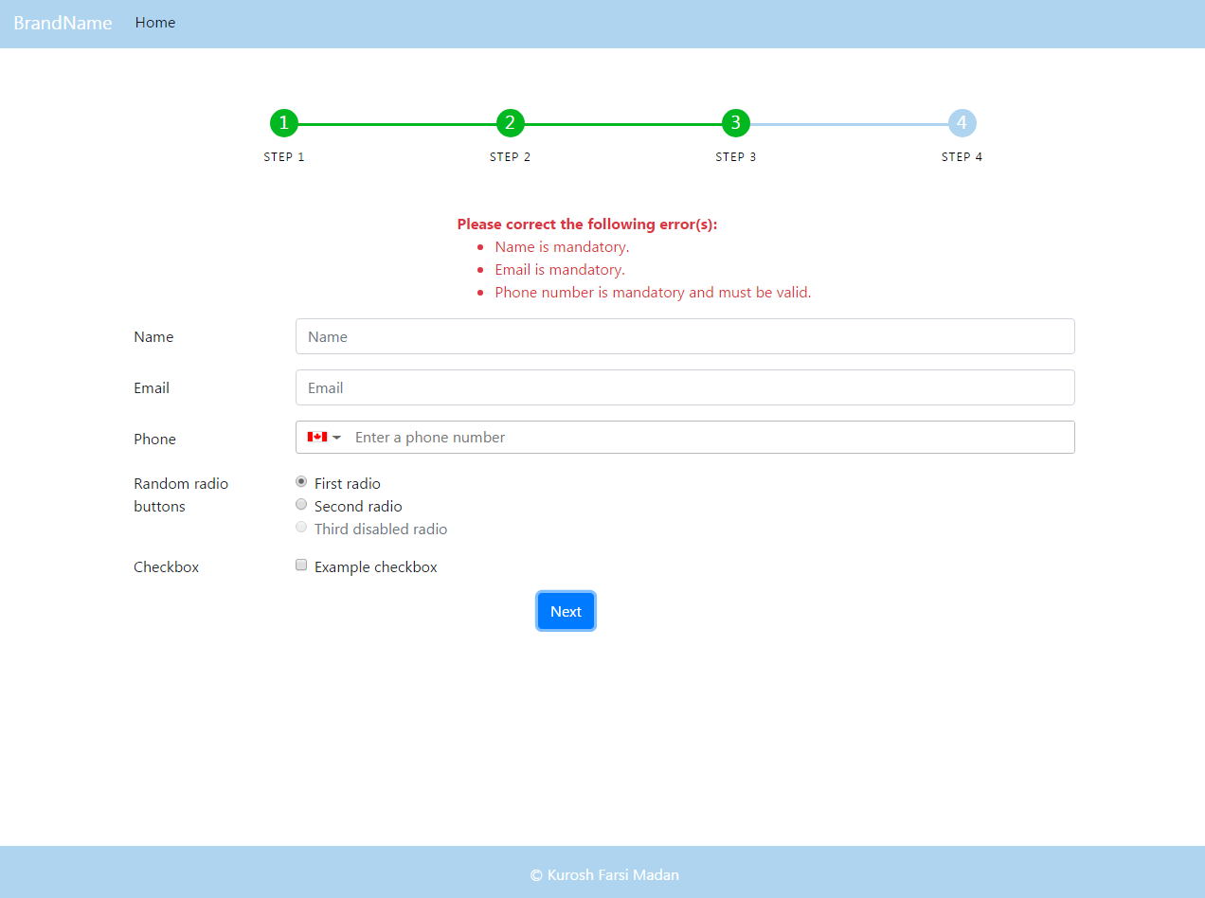

Figure 4. Step 3

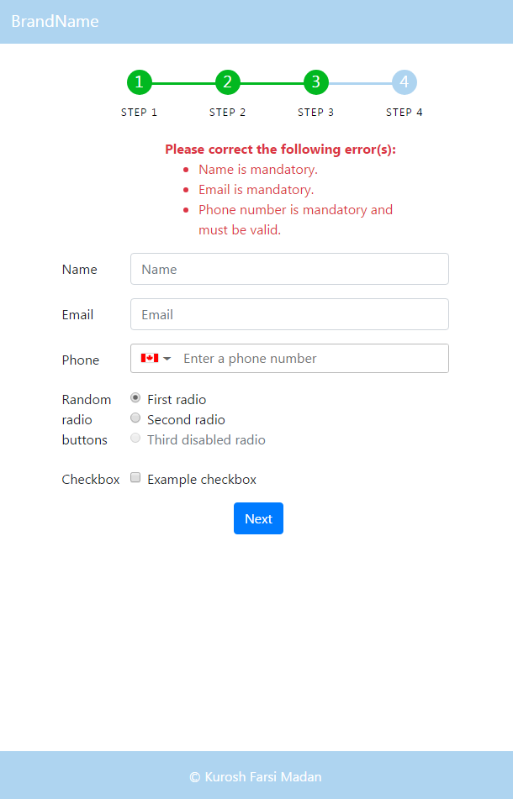

Figure 5. Responsive Step 3

In the final step, you are shown the data that you selected or inserted into the application. Just press ”Submit” button and you are finished.

# application requirements

The application requirements or todos were like the following

### First step - show a list of uploaded files in a table format (date, time + file name)

### Second step - selecting 1 out of 4 box options - a selection must happen for the user to be able to proceed to the next step

### Third step (Q/A) - entering in 4 field forms: name, address, email and phone number, there must be form validation

### Last step - overview screen of all information collected where they have to confirm before submitting

# Used libraries

Some of the mentionable libraries or frameworks used in this project were

### Vue.js 2

### Bootstrap 4

### Vue-Tel-Input

# REFERENCES

1. https://vuejs.org/v2/cookbook
2. https://getbootstrap.com/docs/4.1/getting-started/introduction/
3. https://www.npmjs.com/package/vue-tel-input